Problem Statement
An e-commerce company wants to leverage its customer, product, order, and sales data to make better business decisions. The objective of this project is to analyze the database using SQL and identify meaningful insights related to customer behavior, product performance, sales trends, and inventory demand.
- You can analyze all the tables by describing their contents.
Task: Describe the Tables:
- Customers
- Products
- Orders
- OrderDetails

Answer :- describe customers;
describe products;
describe orders;
describe OrderDetails;

- Identify the top 3 cities with the highest number of customers to determine key markets for targeted marketing and logistic optimization.

Answer :- In this query, we used the Customers table to identify the top 3 cities with the highest number of customers.

Select location, count(*) as Number_of_customer
from customers
group by location
order by Number_of_customer desc
limit 3;

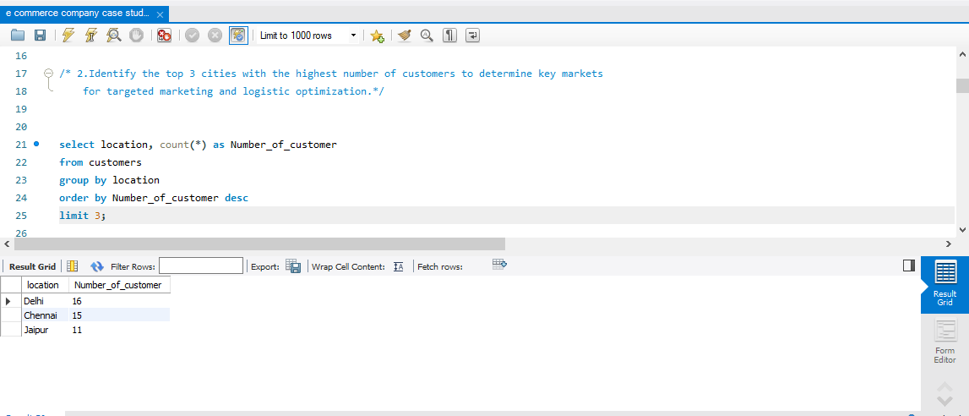

- As per the last query's result, Which of the cities must be focused as a part of marketing strategies?

Answer:- As per the last query’s result, Delhi, Chennai and Jaipur cities must be focused on as part of marketing strategies.

- Determine how many customers fall into each order frequency category based on the number of orders they have placed.

Answer :- In this query we have used the Orders table and calculated each order frequency and customers.

with customer_orders as (
select customer_id,count(*) as order_count
from orders
group by customer_id)

select order_count as numberoforders,
count(*) as customercount
from customer_orders
group by numberoforders
order by customercount desc;

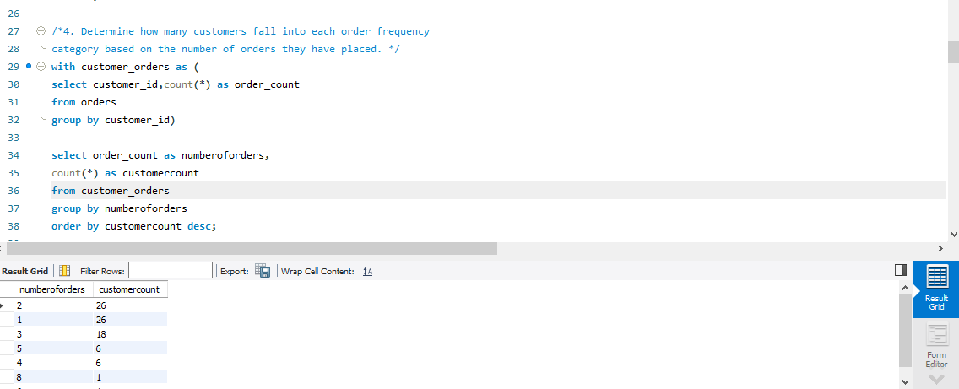

- As per the Engagement Depth Analysis question, What is the trend of the number of customers v/s number of orders?

Answer :- As the number of orders increases and the count of customers decreases.

- As per the Engagement Depth Analysis question, Which customers category does the company experiences the most?

Answer :- The Occasional shoppers category is experienced the most by the company.

- Identify products where the average purchase quantity per order is 2 but with a high total revenue, suggesting premium product trends.

Answer :- In this query we are calculating average purchase quantity per order is 2 and highest total revenue. In the query we have used orders table.

select product_id,avg(quantity) as AvgQuantity,
sum(price_per_unit*quantity) as totalRevanue
from orderdetails
group by product_id
having AvgQuantity =2;

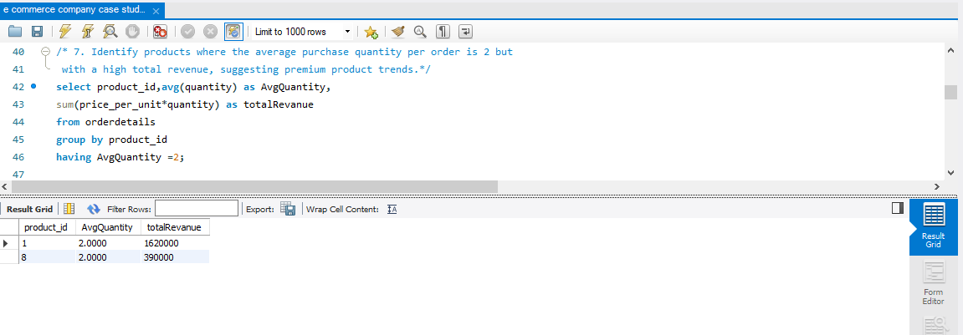

- Among products with an average purchase quantity of two, which ones exhibit the highest total revenue?

Answer :- Product 1 has exhibits the highest total revenue.

- For each product category, calculate the unique number of customers purchasing from it. This will help understand which categories have wider appeal across the customer base.

Answer :- In this query ,we have calculated the Unique number of customers for each product category and we have used the Products , Orderdetails and Ordres table.
select a.category,count(distinct c.customer_id) as unique_customers
from products a
join orderDetails b
on a.product_id =b.product_id
join orders c
on b.order_id =c.order_id
group by 1
order by 2 desc;

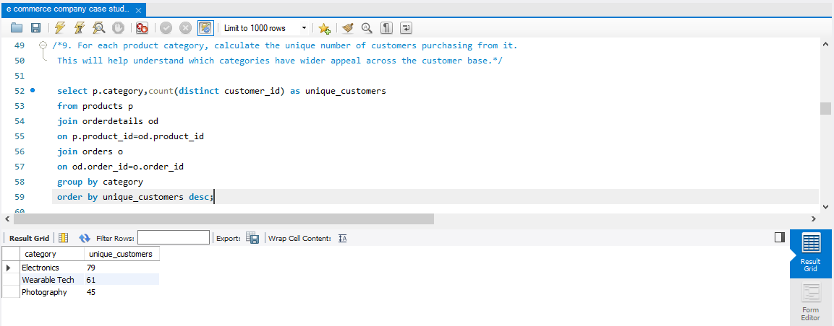

- As per the last question, Which product category needs more focus as it is in high demand among the customers?
Answer :- The Electronics product category needs more focus as it is in high demand among the customers.

- Analyze the month-on-month percentage change in total sales to identify growth trends.
Answer :- In this query, we have analyzed the month-on-month percentage change in total sales and we have used Orders table.

with cte1 as(select date_format(order_date,"%Y-%m") as Month,
sum(Total_amount) as TotalSales
from orders
group by 1),
cte2 as (select *,
lag(TotalSales) over (order by month) as previous_month_sales
from cte1)
select Month,TotalSales,round(
((TotalSales-previous_month_sales)/previous_month_sales)*100,2) as PercentChange
from cte2;
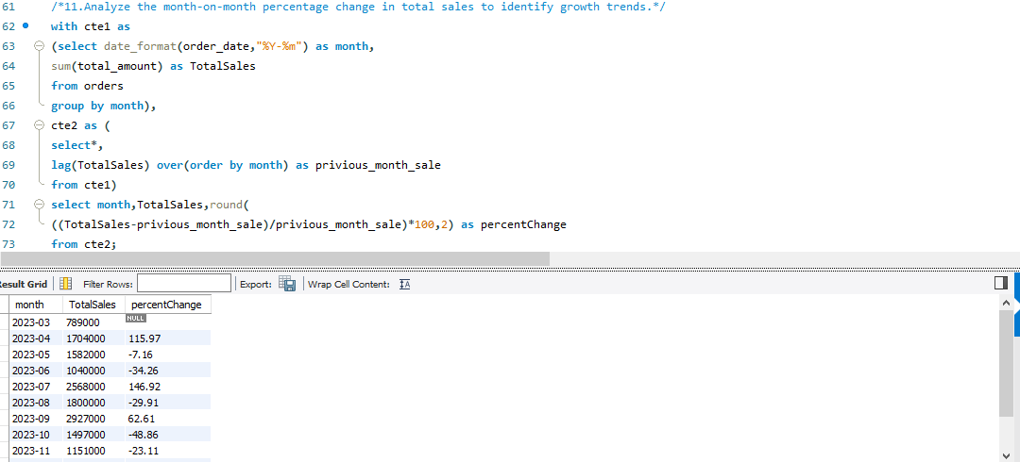

- As per Sales Trend Analysis question, During which month did the sales experience the largest decline?

Answer :- The sales experienced the largest decline in Feb 2024 .

- As per Sales Trend Analysis question, What could be inferred about the sales trend from March to August?

Answer :- From march to august, sales fluctuated with no clear trend.

- Examine how the average order value changes month-on-month. Insights can guide pricing and promotional strategies to enhance order value
Answer :- In this query, we have calculated average order value and then month-on-month change order value.we have used the orders table.

with cte1 as(
select date_format(order_date,"%Y-%m") as month,
round(avg(total_amount),2) as AvgOrderValue
from orders
group by month),
cte2 as (select *,
lag(AvgOrderValue) over(order by month) as privious_month_sale
from cte1)
select month,AvgOrderValue,round(
(avgordervalue-privious_month_sale),2) as ChangeInValue
from cte2
order by changeinvalue desc;
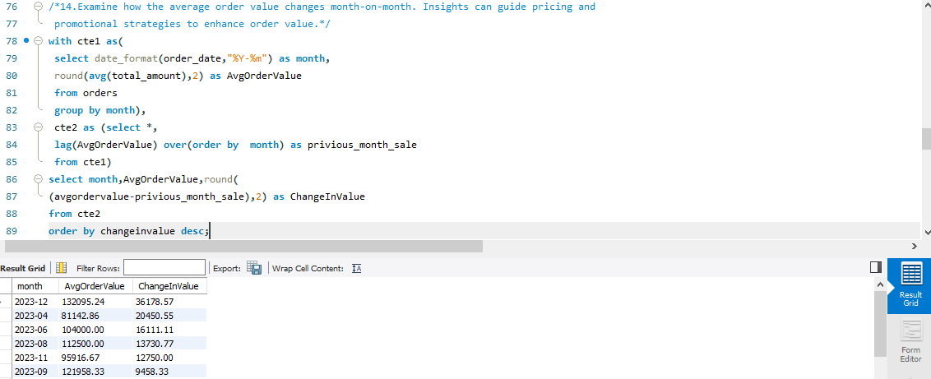

- As per last question, Which month has the highest change in the average order value?

Answer :- December month has the highest change in the average order value.

- Based on sales data, identify products with the fastest turnover rates, suggesting high demand and the need for frequent restocking.
Answer :- In the query, we have found product with fastest turnover rates and we have used the Orderdetails table.

select product_id,count(*) as SalesFrequency
from orderdetails
group by product_id
order by salesFrequency desc
limit 5;

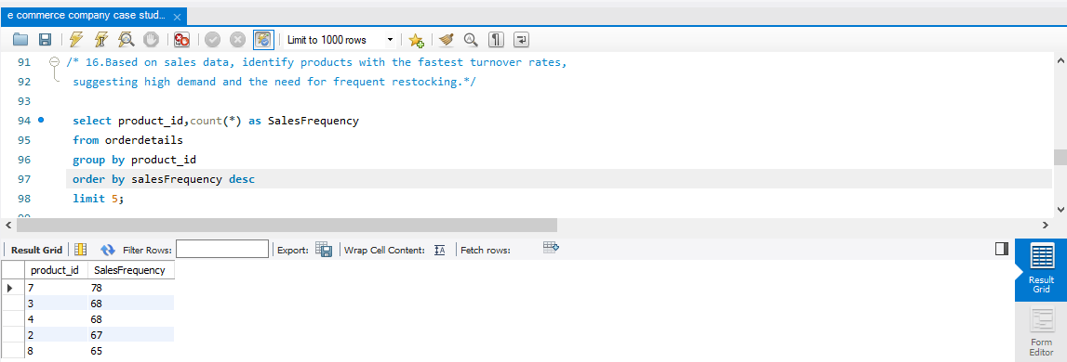

- As per last question, Which product_id has the highest turnover rates and needs to be restocked frequently?

Answer :- Product_id 7 has the highest turnover rates and needs to be restocked frequently.

- List products purchased by less than 40% of the customer base, indicating potential mismatches between inventory and customer interest.

Answer :- In the query, we have found unique customers and products purchased by less than 40% and we have used the Products , Orders, Orderdetails and Customer table.

select p.product_id ,p.name,count(distinct o.customer_id) as UniqueCustomerCount
from products p
join orderdetails od
on p.product_id = od.product_id
join orders o
on o.order_id= od.order_id
group by p.product_id,p.name
having UniqueCustomerCount< (select count(*) *0.40 from customers);

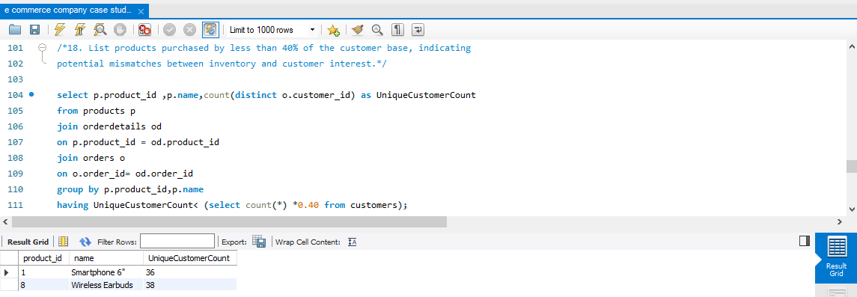

- Why might certain products have purchase rates below 40% of the total customer base?

Answer :- Certain products might have purchase rates below 40% due to poor visibilty on the platform.

- After running an analysis to identify products purchased by less than 40% of the customer base, it was found that a few products have lower purchase rates than expected.

What could be a strategic action to improve the sales of these underperforming products?

Answer :- Implementing targetedmarketing campaigns to raise product awareness and interest.

- Evaluate the month-on-month growth rate in the customer base to understand the effectiveness of marketing campaigns and market expansion efforts.

Answer :- In the query, we have count of the number of customers who made the first purchase on monthly basis and we have used the Orders table.

with first_purchase as(
select customer_id, min(order_date) as first_Order_date
from orders
group by customer_id)

select date_format(first_order_date,"%Y-%m") as FirstPurchaseMonth,
count(customer_id) as TotalNewCustomer
from First_purchase
group by FirstPurchaseMonth
order by FirstPurchaseMonth;

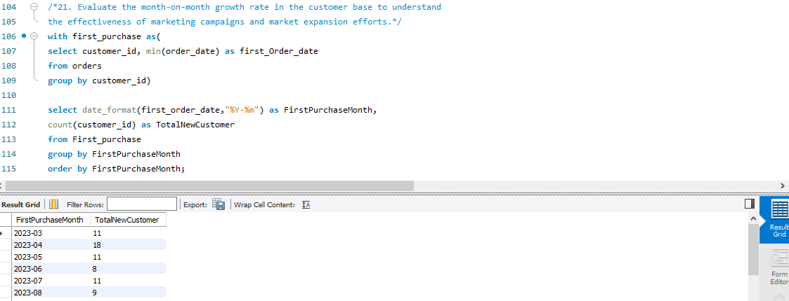

- As per last question, What can be inferred about the growth trend in the customer base from the result table?

Answer :- It is downward trend which implies the marketing campaign are not much effective.

- Identify the months with the highest sales volume, aiding in planning for stock levels, marketing efforts, and staffing in anticipation of peak demand periods.

Answer :- In the query, we have Identified months with total sales and we have used Orders table.

select date_format(order_date,"%Y-%m") as Month,
sum(total_amount) as TotalSales
from orders
group by Month
order by TotalSales desc
limit 3;

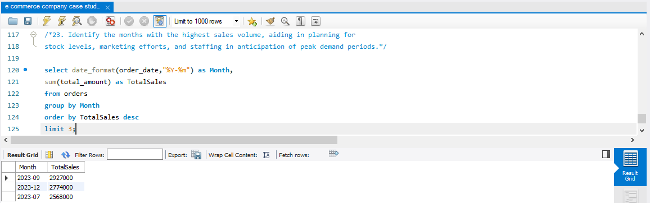

- As per last question, Which months will require major restocking of product and increased staffs?

Answer :- September and December months will require major restocking of product and increased staffs.

